Seasonal Reorganization of Climate Similarity in the Carpathian Basin: A Time-Based Climate Network Approach
Attila MAGYARI-SÁSKA
Abstract
This study examines changes in the seasonal organisation of climate in the Carpathian Basin using a time-based climate-network approach. In contrast to conventional climate networks, where nodes usually represent spatial locations, the present method defines individual year–month observations as network nodes. Edges describe multidimensional climatic similarity based on monthly values derived from daily temperature, precipitation, humidity and radiation data. The analysis uses E-OBS gridded observational data for ten selected locations and compares two 30-year periods: 1961–1990 and 1995–2024. The results show that the annual climatic cycle remained broadly recognisable in the recent period, with stable winter and summer components still present in the network structure. However, the boundaries between seasonal groups became less sharply defined. The strongest changes were associated with transition months, especially February, March, April, September and October. Shannon entropy indicates that some of these months became more fragmented, while prototype similarity matrices reveal stronger cross-seasonal relationships between spring and autumn states. Percolation analysis shows only minor changes in overall network robustness, suggesting that the observed transformation should not be interpreted as a collapse of the seasonal structure, but rather as a moderate reorganisation of the relationships between monthly climatic states. The study demonstrates that time-based climate networks can complement conventional trend-based climate analyses by highlighting structural changes in the temporal organisation of seasonality.
Keywords: time-based climate networks; seasonal reorganisation; Carpathian Basin; climatic similarity; Shannon entropy; percolation analysis
1. INTRODUCTION
Climate change is usually described through changes in individual climatic variables, such as temperature, precipitation, humidity or radiation (Stine et al., 2009; Stine and Huybers, 2012). These variables are commonly analysed by trends, anomalies, extremes or spatial patterns, and such approaches remain essential for understanding regional climate dynamics. At the same time, climate is not experienced as a set of isolated variables. It is organised through recurring seasonal states, transitions between months, and similarities between different parts of the annual cycle. For this reason, changes in climate may also appear as changes in the internal structure of seasonality: some months may become more similar to others, some transitional periods may become less clearly defined, and the stability of the annual cycle may be modified even when the general seasonal order remains recognisable (Stine et al., 2009; Hajek et al., 2022).
This structural perspective is particularly relevant in regions where several climatic influences meet like in the Carpathian Basin (Spinoni et al., 2015b). Situated between Central and South-Eastern Europe, it is shaped by oceanic, continental and local topographic influences. Its climate is therefore not only spatially heterogeneous, but also strongly seasonal. The basin includes lowland areas, enclosed depressions, hilly regions and mountain-influenced zones, all of which may respond differently to ongoing climatic change. Previous research has already shown that the region is sensitive to changes in temperature and precipitation regimes, with consequences for agriculture, water resources and environmental stability (Bartholy and Pongrácz, 2007; Spinoni et al., 2015a; Spinoni et al., 2015b; Jánosi et al., 2023; Megyeri-Korotaj et al., 2023). However, beyond changes in the magnitude of climatic variables, it is also important to ask whether the temporal organisation of the regional climate has changed. Network-based methods offer a useful framework for this type of question (Tsonis and Roebber, 2004; Tsonis et al., 2006; Donges et al., 2009). In climate research, networks are most often used to represent spatial relationships: nodes usually correspond to grid cells or meteorological stations, while edges describe statistical similarity, correlation or coupling between climatic time series (Tsonis and Roebber, 2004; Donges et al., 2009; Holme and Rocha, 2023). Such spatial climate networks have been applied to the study of teleconnections, climate regimes and large-scale atmospheric patterns, including phenomena such as El Niño (Ludescher et al., 2023). This line of research has shown that graph-based representations can reveal structural properties of the climate system that are not always visible through conventional statistical summaries.
The temporal dimension of climate similarity has received less attention (Holme and Saramäki, 2012; Mucha et al., 2010). If spatial climate networks ask how different places are connected through climate behaviour, a time-based climate network asks a different question: how are different time periods connected to each other? From this perspective, months or seasons can be treated as elements of a climatic system (Holme and Saramäki, 2012; Stine et al., 2009). Their relationships can be described by the similarity of their multidimensional climatic conditions. Such an approach is especially suitable for investigating whether the annual cycle has become more fragmented, more internally differentiated, or more strongly reorganised over time.
The study is guided by three main questions. First, can a time-based network representation reveal changes in the seasonal organisation of climate in the Carpathian Basin? Second, which parts of the annual cycle show the strongest structural reorganisation between the two periods? Third, do these changes indicate a general weakening of the climatic network, or rather a reconfiguration of seasonal relationships while the overall annual structure remains stable? By addressing these questions, the paper contributes both to regional climate analysis and to the methodological development of climate-network research. Its regional contribution lies in identifying how the internal seasonal structure of the Carpathian Basin has changed during the last six decades. Its methodological contribution lies in adapting established tools of network analysis, including similarity-based graph construction, community detection, entropy measures and percolation analysis, to a temporal-node framework (Fan et al., 2018). This makes it possible to study climate not only as a spatially connected system, but also as a temporally organised structure.
2. Study Area and Data
The analysis focuses on the Carpathian Basin, a climatically diverse region situated in Central and South-Eastern Europe. The basin is shaped by the combined influence of oceanic, continental and local topographic factors, which makes it suitable for examining changes in the seasonal organisation of climate. Instead of analysing the entire basin as a single homogeneous unit, the study uses ten selected locations that represent the main physiographic and local climatic settings of the region. These locations are Győr, Kecskemét, Keszthely, Pécs, Košice, Oradea, Cluj-Napoca, Gheorgheni, Deva and Brașov (Fig. 1). The selection was intended to cover a broad range of regional conditions, from the more open lowland parts of the Pannonian Basin to transitional foothill areas and more enclosed intra-mountain depressions. In this way, the analysis keeps the dataset manageable while still retaining the main geographical contrasts that are relevant for the interpretation of seasonal climate-network change.
For each location, the corresponding grid cell of the E-OBS gridded observational dataset was used. The data were obtained from the Copernicus Climate Data Store and consist of daily climatic observations derived from station-based records and spatial interpolation. Six daily variables were extracted for each selected location: daily mean temperature (TG), daily minimum temperature (TN), daily maximum temperature (TX), daily precipitation sum (RR), daily mean relative humidity (HU) and daily mean global radiation (QQ) to describe each month as a multidimensional climatic state.
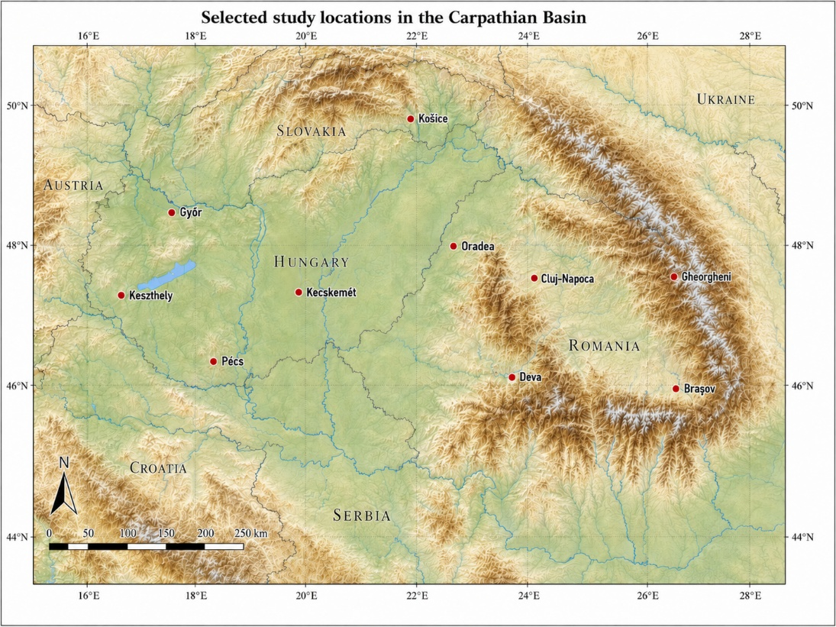
Fig. 1. Study locations in the Carpathian Basin
Each month in each year therefore became one observation described by a six-dimensional climatic vector. The temporal coverage was divided into two 30-year periods. The early period extends from January 1961 to December 1990, while the late period extends from January 1995 to December 2024. These two intervals were selected to compare a historical baseline with a more recent climatic period of the same length.
3. Methodology
Since the six variables have different units and numerical ranges, the monthly feature vectors were first standardised. This step prevents variables with larger absolute values, such as precipitation totals, from dominating the distance calculation. After standardisation, Principal Component Analysis (PCA) was applied to reduce the six-dimensional space to two dimensions to obtain a compact space in which the main multidimensional differences between months are preserved. Similarity was then calculated from the Euclidean distance between monthly observations in this reduced PCA space. For two nodes ($i$) and ($j$), with projected coordinates ($p_{i}$) and ($p_{j}$), the distance was calculated as (Eq. 1):
$$d\left(i,j\right)=\sqrt{{\left(p_{i,1}-p_{j,1}\right)}^{2}+{\left(p_{i,2}-p_{j,2}\right)}^{2}}$$ | (1)
The distances were transformed into similarity values using min–max scaling followed by inversion (Eq. 2):
$$S\left(i,j\right)=1-\frac{d\left(i,j\right)-d_{min}}{d_{max}-d_{min}}$$ | (2)
Thus, a value close to 1 means that two months occupy a very similar position in the reduced climatic space, while lower values indicate more distinct monthly states. For the early and late networks, the same reference scale was used. The minimum and maximum distances used in the transformation were derived from the full available period, so that similarity values in the two networks remained directly comparable.
The pairwise similarity calculation initially produces a complete weighted graph, where each month is connected to all other months. For a meaningful interpretation a pruning step was applied to extract the main structural backbone of the network. All edges were ranked according to their similarity values, and the weakest edges were removed until a predefined average degree was reached. For this, instead of using a fixed similarity threshold, the method therefore keeps network density comparable between locations and periods. The target average degree was defined as (Eq. 3):
$$\left\langle k\right\rangle =3Y-1$$ | (3)
where ($Y$) is the number of years in the analysed period. Since both comparison periods contain 30 years, this gives a target average degree of 89. The corresponding number of retained edges is (Eq. 4):
$$E_{target}=\frac{\left\langle k\right\rangle ×N}{2}$$ | (4)
where ($N$) is the number of nodes in the network. This rule follows the assumption that, under stable seasonal conditions, a month should remain strongly connected to its own calendar-month occurrences in other years and to the neighbouring parts of the annual cycle. The weight of the weakest retained edge defines the empirical structural threshold of the given network.
The community structure analysis aim was to identify groups of month-year observations that form internally coherent climatic blocks. In this context, a community can be interpreted as a set of months that are more similar to each other than to the rest of the annual cycle (Newman, 2006). The Leiden algorithm was used for community detection, with edge weights included in the partitioning process (Traag et al., 2019). The resulting communities were not interpreted only as abstract graph clusters, but they were compared with calendar months in order to see whether the detected structure follows the expected seasonal order, and whether this order changes between the early and late periods. The quality of the detected partition was summarised by modularity, which measures how strongly nodes are grouped within communities compared with the connections expected in a random network. Higher modularity indicates more clearly separated seasonal blocks, while lower modularity indicates weaker separation and stronger overlap between seasonal communities.
To describe how stable or fragmented each calendar month is within the detected communities, Shannon entropy was calculated for every month (Shannon, 1948). For a given calendar month, the distribution of its 30 year–month observations across communities were used. The entropy of month ($m$) was calculated as (Eq. 5):
$$H_{m}=\sum_{c=1}^{C}{p_{m,c}*ln⁡(p_{m,c})}$$ | (5)
where ($p_{m,c}$) is the proportion of observations of month ($m$) assigned to community ($c$), and ($C$) is the number of communities containing observations from that month. Higher entropy values indicate a more fragmented or transitional monthly position, while lower values indicate a more stable community membership.
Community detection and entropy describe the internal structure of each period separately. To compare the typical position of calendar months between the early and late periods, prototype similarity matrices were also calculated. For each location and each period, a monthly prototype was created for every calendar month, representing the average climatic state of that month over the 30-year period. The early and late prototypes were projected into the same PCA-based reference space used for the network construction. Similarities were then calculated between all early and late monthly prototypes, producing a 12 × 12 matrix.
Percolation analysis was used to describe the robustness of the entire network. The procedure examines how the network breaks apart when weaker edges are progressively removed. For each network, a series of increasing similarity thresholds was applied. At each threshold, only edges with weights equal to or higher than the threshold were kept. The size of the largest connected component was then calculated as a proportion of all nodes. As the threshold increases, the network gradually loses edges and eventually fragments. The critical percolation threshold was defined as the threshold before the largest drop in the size of the largest connected component. This point marks the similarity level at which the network loses a major part of its connectivity. A higher critical threshold means that the network remains connected even when only strong similarities are kept. A lower critical threshold indicates earlier fragmentation. To compare the two periods, a percolation index was calculated as (Eq. 6):
$$I_{perc}=τ_{c}^{late}-τ_{c}^{early}$$ | (6)
where ($τ_{c}^{early}$) and ($τ_{c}^{late}$) are the critical thresholds of the early and late networks. Positive values indicate that the late network is more robust than the early one, while negative values indicate that it fragments at a lower similarity threshold.
4. Results
4.1. General structure of the time-based climate networks
The comparison of the early and late time-based climate networks shows that the annual climatic cycle did not undergo a complete structural breakdown. In most cases, the detected communities still followed a broad seasonal logic. The networks were usually organised around three main blocks, corresponding to winter, summer and transitional months. In a few cases, a fourth community also appeared, but this did not represent a new stable seasonal regime. It was generally linked to the separation of one or a small number of isolated nodes. The more relevant change was not the number of communities itself, but the way in which these communities became connected to each other. Modularity decreased at all ten selected locations between the early and late periods (Fig. 2). This indicates that the seasonal blocks became less sharply separated in the contemporary period. The winter and summer cores remained identifiable, but the boundaries between the main seasonal groups became weaker.
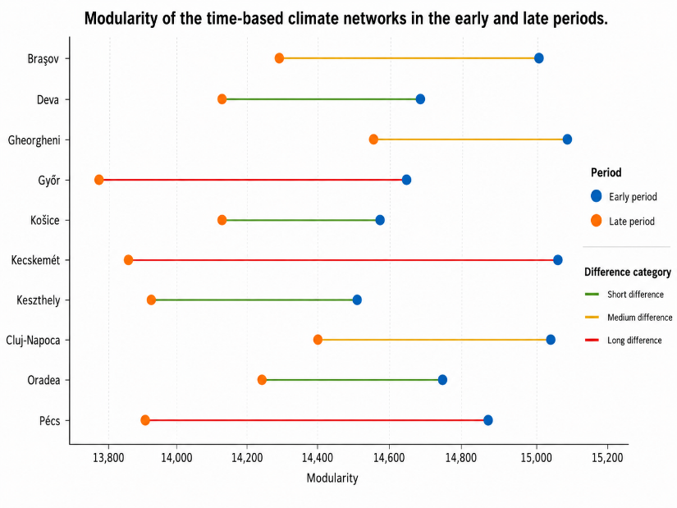
Fig. 2. Change in modularity between the early and late periods.
This pattern is important as suggests a reorganisation of the seasonal structure rather than a simple increase or decrease in climatic variability. The annual cycle remained recognisable, but the internal separation between its main components became less clear. The most visible changes were connected to the months located near seasonal boundaries, especially late winter, spring and early autumn. The community-detection results therefore provide the first indication that the contemporary climate networks are not simply more fragmented in a general sense. Instead, they show a more subtle change: stable seasonal cores are preserved, while the transition zones between them become more flexible and less clearly delimited.
4.2. Monthly fragmentation based on Shannon entropy
Shannon entropy gives a more detailed view of how the individual calendar months changed between the two periods. Low entropy values indicate that the observations of a given month are concentrated in one community, while higher values show that they are distributed across several communities. In this sense, entropy describes how stable or ambiguous the community membership of a month is.
The monthly results show that the changes were not uniform throughout the year. January and December remained completely stable in both periods, with average Shannon entropy values of 0.000. These months were consistently assigned to a single winter community at all selected locations. A similarly stable pattern appears in the core summer months. June, July and August show only very small changes, which confirms that the middle of the warm season preserved a relatively coherent network position (Fig. 3).
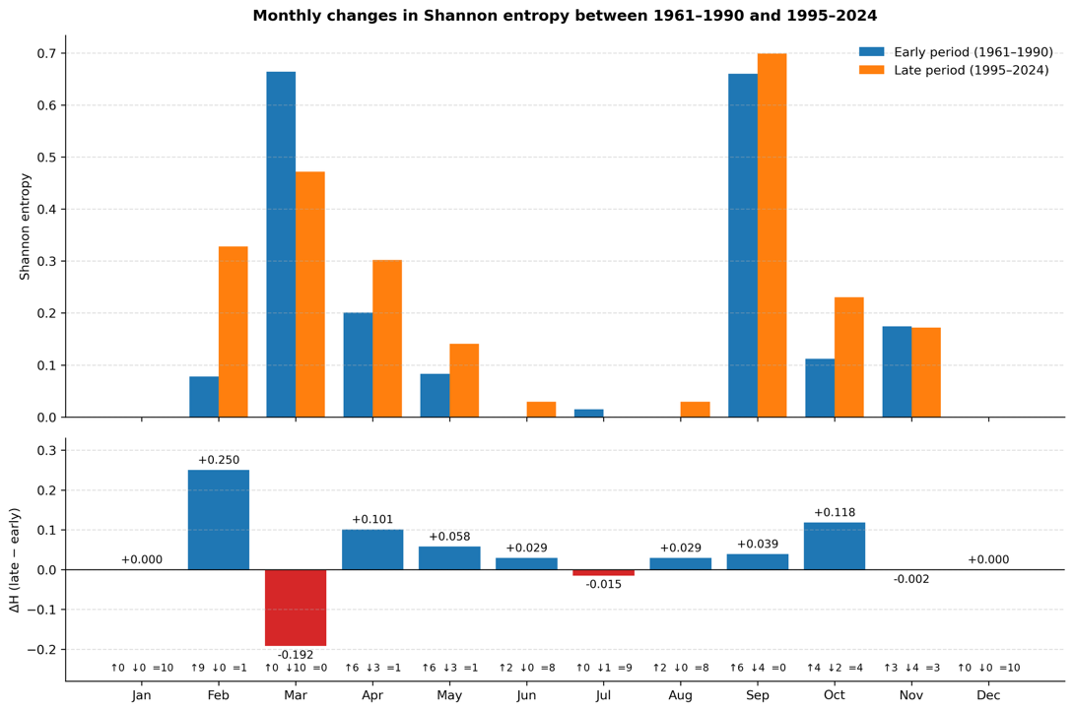
Fig. 3. Monthly Shannon entropy in the early and late periods.
The strongest increase was observed in February. Its average Shannon entropy increased from 0.078 in the early period to 0.328 in the late period. This increase was present at nine of the ten selected locations (Figure 3.). The result suggests that February became less firmly attached to a single winter community and more frequently shared similarities with transitional climatic states. In other words, late winter became a more ambiguous part of the annual cycle in the contemporary period.
March shows the opposite pattern. Its average entropy decreased from 0.664 to 0.472, and the decrease occurred at all ten locations (Figure 3.). This does not mean that the spring transition disappeared. Rather, it suggests that March became less divided between winter-like and spring-like communities. In the early period, March often occupied a mixed position between seasonal groups. In the late period, it became more concentrated in a clearer transitional or spring-related structure.
April and May both show moderate increases in entropy. April increased from 0.201 to 0.302, while May increased from 0.083 to 0.141. These changes were not as strong as in February, but they still point to a broader reorganisation of the spring transition. The spring season therefore appears not as a uniform shift, but as a sequence of month-specific changes: February becomes more fragmented, March becomes more clearly repositioned, and April–May show moderate diversification (Figure 4.).
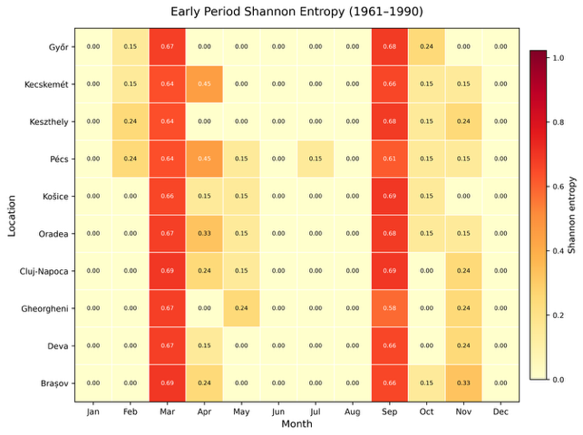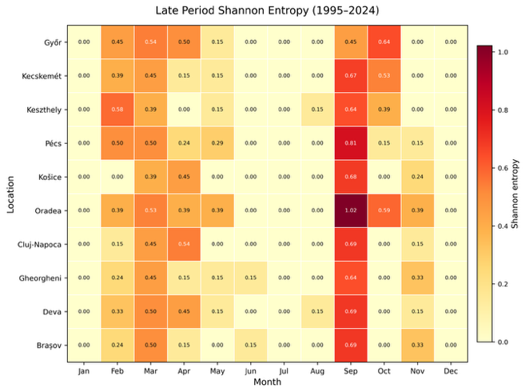
Fig. 4. Early and Late Period Shannon Entropy by Locations
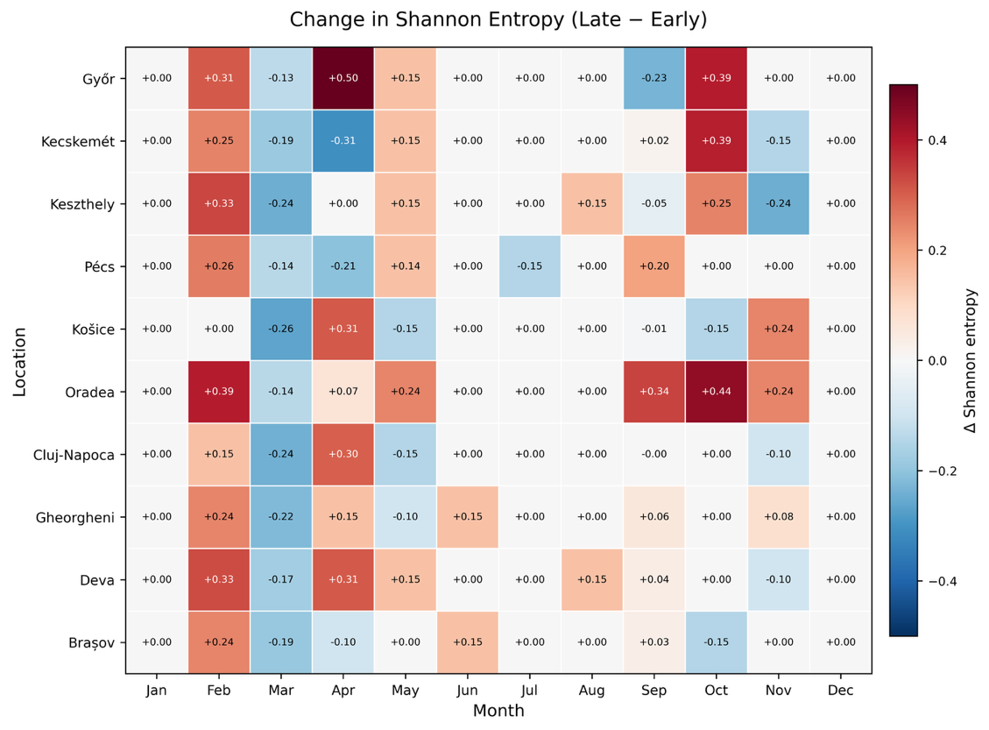
Fig. 5. Changes in Shannon-entropy by Location
September remained one of the most complex months in the annual cycle. Its entropy was already high in the early period, with an average value of 0.660, and increased slightly to 0.699 in the late period. This confirms that September has a persistently transitional character. It does not behave as a stable late-summer or early-autumn month only, but as a climatic boundary zone where different seasonal signals overlap (Figure 5.).
October also became more fragmented, with entropy increasing from 0.112 to 0.230. November, however, remained almost unchanged, decreasing only slightly from 0.174 to 0.172. Taken together, the autumn results suggest that the strongest late-year reorganisation is concentrated around September and October, while November is more variable from place to place.
Overall, the entropy results support the interpretation derived from community detection. The core months of winter and summer remained relatively stable, while the months at the edges of seasons showed the most important structural changes. The annual cycle therefore changed mainly through the reorganisation of its transition months.
4.3. Prototype similarities and cross-seasonal shifts
The prototype similarity matrices provide a direct comparison between the typical monthly climatic states of the early and late periods. They help to identify whether the same calendar months remained close to their earlier climatic position, or whether stronger cross-seasonal similarities appeared.
The general pattern confirms that the main annual structure was preserved. Winter months remained most similar to winter-like late-period states, and the summer months continued to form a clearly recognisable warm-season block. This means that the basic seasonal order did not disappear. The networks do not indicate a collapse of the annual cycle into an undifferentiated structure (Figure 6.).
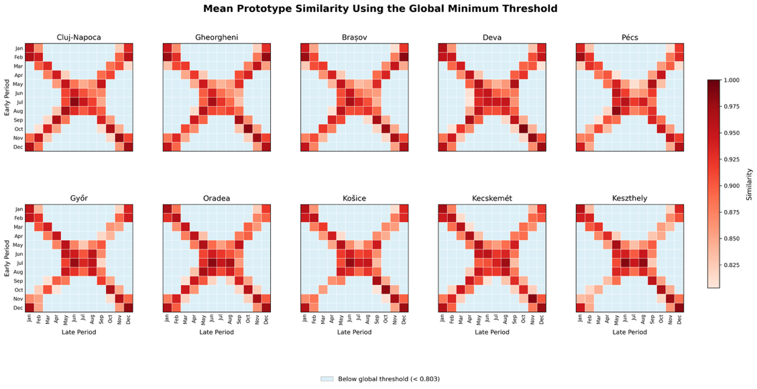
Fig. 6. Prototype Matrices by Location
The most informative changes appear outside the diagonal of the prototype matrices. These off-diagonal similarities show where months from the early period became strongly connected to different months in the late period. After applying the structural thresholds, several spring–autumn and late-summer–autumn overlaps remained visible. This indicates that these similarities were not only weak background relations, but part of the stronger network structure.
The case of Pécs illustrates this pattern clearly (Figure 7.). In the thresholded prototype matrix, early April shows a very high similarity to late October, with a value of 0.95. Early May is most strongly linked to late September, with a similarity of 0.97. These values point to a stronger overlap between spring, late-summer and autumn transitional states. The result should not be interpreted as a direct replacement of one month by another, but rather as evidence that the climatic similarity field of transitional months became more interconnected.
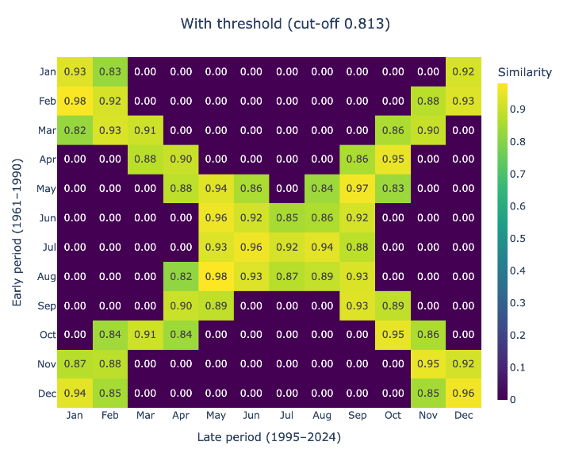
Fig. 7. Thresholded prototype similarity matrix of Pécs.
Similar patterns also appear at other locations, although with different strength. The thresholded matrices show that even after removing weaker background similarities, the transition periods retain important cross-seasonal links. This is consistent with the entropy results: the largest changes are not located in the stable winter and summer cores, but in the months where seasonal identities are naturally less fixed.
The prototype analysis therefore adds an important layer to the results. Community detection shows that the seasonal blocks became less sharply separated, and Shannon entropy identifies which months became more or less fragmented. The prototype matrices show how this reorganisation appears in terms of direct month-to-month similarity between the two periods.
4.4. Percolation robustness
Percolation analysis was used to evaluate whether the observed seasonal reorganisation also involved a weakening of the whole network backbone. The results show that this was not the case in a strong sense. The percolation indices remained close to zero at the selected locations, indicating only moderate changes in global network robustness.
Across the ten locations, the percolation index ranged from −0.01419 to +0.01002, with an average value of −0.00257. The average direction of change was therefore slightly negative, meaning that the late-period networks tended to fragment at somewhat lower similarity thresholds. However, the magnitude of this change was small. It does not support the interpretation of a general collapse in network connectivity.
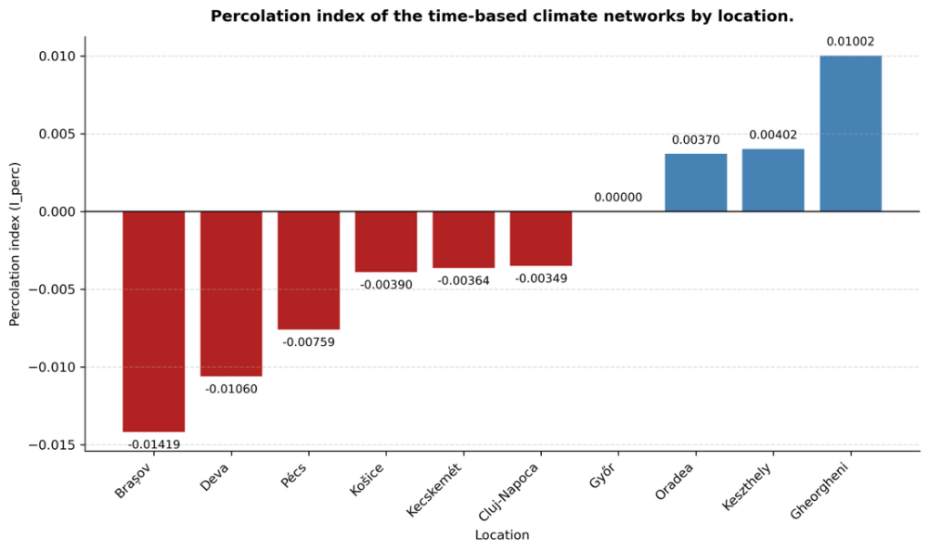
Fig. 8. Percolation index by location.
The locations can be grouped into three broad categories (Figure 8.). The first group includes locations with negative percolation indices, where the late-period network became slightly more fragile. This group includes Brașov, Deva, Pécs, Košice, Kecskemét and Cluj-Napoca. The strongest negative shift was found in Brașov (Figure 9.), where the index reached −0.01419 and the critical threshold decreased from approximately 0.971 to 0.957. Deva also showed a relatively stronger negative value, while the changes at Košice, Kecskemét and Cluj-Napoca were smaller.
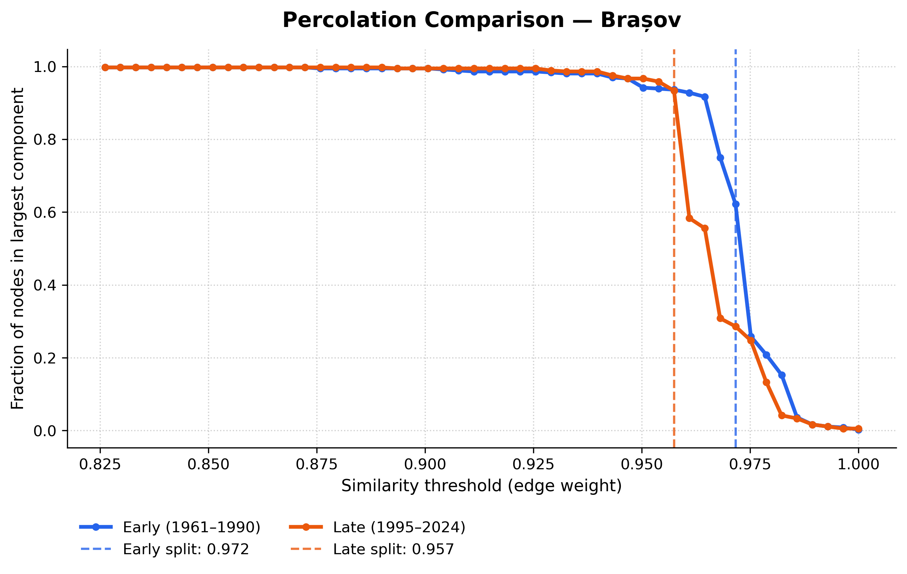
Fig. 9. Percolation Comparison for Brasov
A second group includes locations where the index was positive, in our case Győr. In these cases, the late-period network remained connected up to a slightly higher similarity threshold. This shows that local or monthly reorganisation does not necessarily mean that the full network becomes weaker. A network can become more internally differentiated while its strongest connections remain stable or even slightly stronger.
The third group consists of locations where the percolation index presents positive values: Gheorgheni, Oradea and Keszthely. At these sites, the percolation curves suggest that a local gain in structural robustness is present.
The percolation results therefore add a necessary qualification to the community and entropy findings. The climate networks became more complex in their seasonal organisation, especially around transition months, but this did not translate into a major loss of global network integrity. The main signal is a reconfiguration of seasonal relationships, not a collapse of the temporal climate network.
5. Discussion
The results suggest that the recent climatic transformation of the Carpathian Basin cannot be described only as a change in the magnitude of individual variables. The time-based network approach shows that the relationships between months also changed. This is an important distinction. A warming climate may preserve the broad order of the annual cycle, while still modifying the way in which individual months resemble each other. The results of this study point exactly in this direction: the winter and summer cores remained clearly recognisable, but the transition zones between them became less stable and more internally connected.
This finding is consistent across the different network indicators. Community detection shows that the main seasonal blocks did not disappear. Shannon entropy shows that the strongest changes occurred in months with a transitional position. Prototype similarities show that some spring and autumn monthly states became more closely related across the two periods. Percolation analysis, in turn, shows that this reorganisation did not lead to a major loss of global network robustness. Taken together, these results indicate a structural rearrangement of seasonality rather than a collapse of the annual climatic cycle.
The most relevant changes are concentrated around the margins of the seasons. February, March, April, September and October are especially important in this respect. These months are not simply intermediate points between winter and summer. They are periods during which the annual cycle changes direction, and small shifts in temperature, radiation, humidity or precipitation may alter their similarity to neighbouring months. Their higher sensitivity in the network structure is therefore not unexpected, but the time-based network approach makes this sensitivity measurable.
February is one of the clearest examples. Its increasing entropy suggests that it became less consistently attached to the winter community. This may reflect a weakening of its traditional winter character at several locations. March behaves differently: its entropy decreased, which means that it became less dispersed across communities. This does not contradict the idea of seasonal reorganisation. Instead, it suggests that March may have moved toward a more coherent transitional or early-spring position. The spring transition therefore did not change in one uniform direction. It became internally rearranged, with different months responding in different ways.
The autumn months also show a similar complexity. September remained one of the most structurally ambiguous months, while October became more fragmented in the late period. This is important because it shows that the reorganisation of seasonality is not limited to spring. The late-summer and autumn boundary also appears to have become more flexible. The prototype similarity matrices support this interpretation, especially where strong links remain between early spring and late autumn states after thresholding. Such links do not mean that one month has simply become another. They rather show that the climatic similarity field of the transition seasons has become more overlapping.
The preservation of the winter and summer cores is equally important. The results do not indicate that the annual cycle has lost its basic seasonal structure. January, December and the middle summer months remained relatively stable in community terms. This suggests that the strongest climatic reorganisation affects the connections between seasonal blocks, not the existence of the blocks themselves. From a climatological point of view, this is a more realistic and more useful interpretation than assuming a general destabilisation of the entire seasonal system.
The percolation results add an important qualification. If the seasonal system had become globally weaker, the late-period networks would be expected to fragment much more easily. This was not observed. The percolation indices remained close to zero, with only small positive or negative changes depending on the location. The implication is that the network backbone remained broadly intact. The main change is therefore not a loss of connectivity, but a redistribution of similarity within the network. This distinction matters because it avoids overstating the results. The networks became more reorganised, but not necessarily less coherent.
The spatial differences between locations also deserve attention. Lowland and transition-zone settings appear to show stronger or clearer reorganisation, while mountain-influenced and enclosed basin environments tend to show more moderate or spatially variable responses. This pattern is plausible in the Carpathian Basin, where topography strongly modifies local climatic conditions. Mountain and intra-basin environments may preserve more specific local seasonal behaviour, while open lowland areas may respond more directly to broader regional warming and moisture changes. However, this interpretation should remain cautious, because the present article works with a limited set of selected locations rather than a full spatial statistical model.
Methodologically, the results show that time-based climate networks can complement conventional climate analysis. Trend analysis is well suited for detecting whether a variable increased or decreased. The present approach asks a different question: how did the internal relationships between monthly climatic states change? This makes it possible to detect structural shifts in the annual cycle that may remain hidden if each variable is examined separately. The method is especially useful when the aim is to study seasonality as an organised system rather than as a sequence of independent monthly averages.
Another advantage of the approach is that it combines several levels of interpretation. Community detection provides a general view of seasonal grouping. Entropy gives a month-level measure of stability or fragmentation. Prototype matrices reveal direct cross-period similarities between typical monthly states. Percolation analysis describes whether the network as a whole remains robust. None of these indicators is sufficient on its own, but together they provide a coherent picture of seasonal reorganisation.
There are also limitations. The analysis is based on E-OBS gridded data, which are interpolated from station observations. This makes the dataset suitable for regional comparison, but it also means that uncertainty may be higher in areas with complex terrain or lower station density. The results should therefore be interpreted as changes in gridded climatic representation, not as direct station-level observations. The selected variables, the PCA representation, the similarity transformation, the pruning strategy and the community-detection algorithm all shape the final network structure. These choices were applied consistently to all locations and periods, which supports comparison, but alternative parameter settings could produce somewhat different network details. For this reason, the results should be read as evidence of robust structural tendencies, not as exact physical boundaries between seasons.
A further limitation is that the study compares two long 30-year periods. This design is useful for contrasting a historical baseline with a contemporary climatic state, but it does not describe the continuous trajectory of change between them. The results therefore show that the seasonal network structure differs between the two periods, but they do not identify the precise timing of the transition. A moving-window version of the same method could address this question in future work.
Despite these limitations, the results support the usefulness of the proposed framework. The time-based network representation captures a form of climatic change that is not limited to trends in individual variables. It shows that the annual cycle of the Carpathian Basin remained recognisable, but its transition months became reorganised and more strongly interconnected. This suggests that recent climate change has affected not only the level of climatic conditions, but also the temporal architecture through which seasonal states are related to one another.
6. Conclusions
This study applied a time-based climate-network approach to examine changes in the seasonal organisation of climate in the Carpathian Basin. By defining individual year–month observations as network nodes, the analysis made it possible to compare the internal structure of the annual cycle between 1961–1990 and 1995–2024.
The results show that the annual climatic cycle remained broadly recognisable in the late period. The main winter and summer components were still clearly present, and the networks did not suggest a general breakdown of seasonality. The most important changes occurred instead at the boundaries between seasons, where the relationships between monthly climatic states became less sharply defined.
Transition months played the central role in this reorganisation. February, March, April, September and October showed the strongest signs of structural change, either through higher fragmentation, clearer repositioning, or stronger cross-seasonal similarity. In contrast, the middle of winter and the middle of summer remained more stable, suggesting that recent climatic change affected mainly the margins of the annual cycle.
The percolation results indicate that this reorganisation did not involve a major loss of network robustness. Most percolation indices remained close to zero, which means that the late-period networks were not substantially more fragile than the early-period networks. The main signal is therefore not a collapse of the temporal climate network, but a moderate rearrangement of its internal structure.
Overall, the study shows that climate change in the Carpathian Basin has affected not only the values of individual climatic variables, but also the temporal relationships between monthly climatic states. The proposed time-based network approach can therefore complement conventional trend-based analyses by highlighting structural changes in the organisation of seasonality.

References
Bartholy, J. and Pongrácz, R. (2007) ‘Regional analysis of extreme temperature and precipitation indices for the Carpathian Basin from 1946 to 2001’, Global and Planetary Change, 57(1–2), pp. 83–95. doi: 10.1016/j.gloplacha.2006.11.002.
Donges, J.F., Zou, Y., Marwan, N. and Kurths, J. (2009) ‘Complex networks in climate dynamics’, The European Physical Journal Special Topics, 174, pp. 157–179. doi: 10.1140/epjst/e2009-01098-2.
Fan, J., Meng, J., Ashkenazy, Y., Havlin, S. and Schellnhuber, H.J. (2018) ‘Climate network percolation reveals the expansion and weakening of the tropical component under global warming’, Proceedings of the National Academy of Sciences of the United States of America, 115(52), pp. E12128–E12134. doi: 10.1073/pnas.1811068115.
Hajek, O.L. and Knapp, A.K. (2022) ‘Shifting seasonal patterns of water availability: ecosystem responses to an unappreciated dimension of climate change’, New Phytologist, 233(1), pp. 119–125. doi: 10.1111/nph.17728.
Holme, P. and Rocha, J.C. (2023) ‘Networks of climate change: connecting causes and consequences’, Applied Network Science, 8(1), article 10, pp. 1–20. doi: 10.1007/s41109-023-00536-9.
Holme, P. and Saramäki, J. (2012) ‘Temporal networks’, Physics Reports, 519(3), pp. 97–125. doi: 10.1016/j.physrep.2012.03.001.
Jánosi, I.M., Bíró, T., Lakatos, B.O., Gallas, J.A.C. and Szöllősi-Nagy, A. (2023) ‘Changing water cycle under a warming climate: Tendencies in the Carpathian Basin’, Climate, 11(6), article 118. doi: 10.3390/cli11060118.
Ludescher, J., Bunde, A. and Schellnhuber, H.J. (2023) ‘Forecasting the El Niño type well before the spring predictability barrier’, npj Climate and Atmospheric Science, 6, article 196. doi: 10.1038/s41612-023-00519-8.
Megyeri-Korotaj, O.A., Bán, B., Suga, R., Allaga-Zsebeházi, G. and Szépszó, G. (2023) ‘Assessment of climate indices over the Carpathian Basin based on ALADIN5.2 and REMO2015 regional climate model simulations’, Atmosphere, 14(3), article 448. doi: 10.3390/atmos14030448.
Mucha, P.J., Richardson, T., Macon, K., Porter, M.A. and Onnela, J.-P. (2010) ‘Community structure in time-dependent, multiscale, and multiplex networks’, Science, 328(5980), pp. 876–878. doi: 10.1126/science.1184819.
Newman, M.E.J. (2006) ‘Modularity and community structure in networks’, Proceedings of the National Academy of Sciences of the United States of America, 103(23), pp. 8577–8582. doi: 10.1073/pnas.0601602103.
Shannon, C.E. (1948) ‘A mathematical theory of communication’, The Bell System Technical Journal, 27(3), pp. 379–423, 623-656. doi: 10.1002/j.1538-7305.1948.tb01338.x.
Spinoni, J., Lakatos, M., Szentimrey, T., Bihari, Z., Szalai, S., Vogt, J. and Antofie, T. (2015a) ‘Heat and cold waves trends in the Carpathian Region from 1961 to 2010’, International Journal of Climatology, 35(14), pp. 4197–4209. doi: 10.1002/joc.4279.
Spinoni, J., Szalai, S., Szentimrey, T., Lakatos, M., Bihari, Z., Nagy, A., Németh, Á., Kovács, T., Mihic, D., Dacic, M., Petrovic, P., Kržič, A., Hiebl, J., Auer, I., Milkovic, J., Štepánek, P., Zahradníček, P., Kilar, P., Limanowka, D., Pyrc, R., Cheval, S., Birsan, M.-V., Dumitrescu, A., Deak, G., Matei, M., Antolovic, I., Nejedlik, P., Štastný, P., Kajaba, P., Bochníček, O., Galo, D., Mikulová, K., Nabyvanets, Y., Skrynyk, O., Krakovska, S., Gnatiuk, N., Tolasz, R., Antofie, T. and Vogt, J. (2015b) ‘Climate of the Carpathian Region in the period 1961–2010: climatologies and trends of 10 variables’, International Journal of Climatology, 35(7), pp. 1322–1341. doi: 10.1002/joc.4059.
Stine, A.R., Huybers, P. and Fung, I.Y. (2009) ‘Changes in the phase of the annual cycle of surface temperature’, Nature, 457, pp. 435–440. doi: 10.1038/nature07675.
Stine, A.R. and Huybers, P. (2012) ‘Changes in the seasonal cycle of temperature and atmospheric circulation’, Journal of Climate, 25(21), pp. 7362–7380. doi: 10.1175/JCLI-D-11-00470.1.
Traag, V.A., Waltman, L. and van Eck, N.J. (2019) ‘From Louvain to Leiden: guaranteeing well-connected communities’, Scientific Reports, 9, article 5233. doi: 10.1038/s41598-019-41695-z.
Tsonis, A.A. and Roebber, P.J. (2004) ‘The architecture of the climate network’, Physica A: Statistical Mechanics and its Applications, 333, pp. 497–504. doi: 10.1016/j.physa.2003.10.045.
Tsonis, A.A., Swanson, K.L. and Roebber, P.J. (2006) ‘What do networks have to do with climate?’, Bulletin of the American Meteorological Society, 87(5), pp. 585–596. doi: 10.1175/BAMS-87-5-585.

Babeș-Bolyai University, Faculty of Mathematics and Computer Science, 400084 Cluj-Napoca, Romania, attila.magyari@stud.ubbcluj.ro

